**Computer Network**

**802.11 WiFi v8.0**

***Lecturer: Mr. Nguyễn Mạnh Thìn***

***Student: Trần Quốc Anh - 1852247***

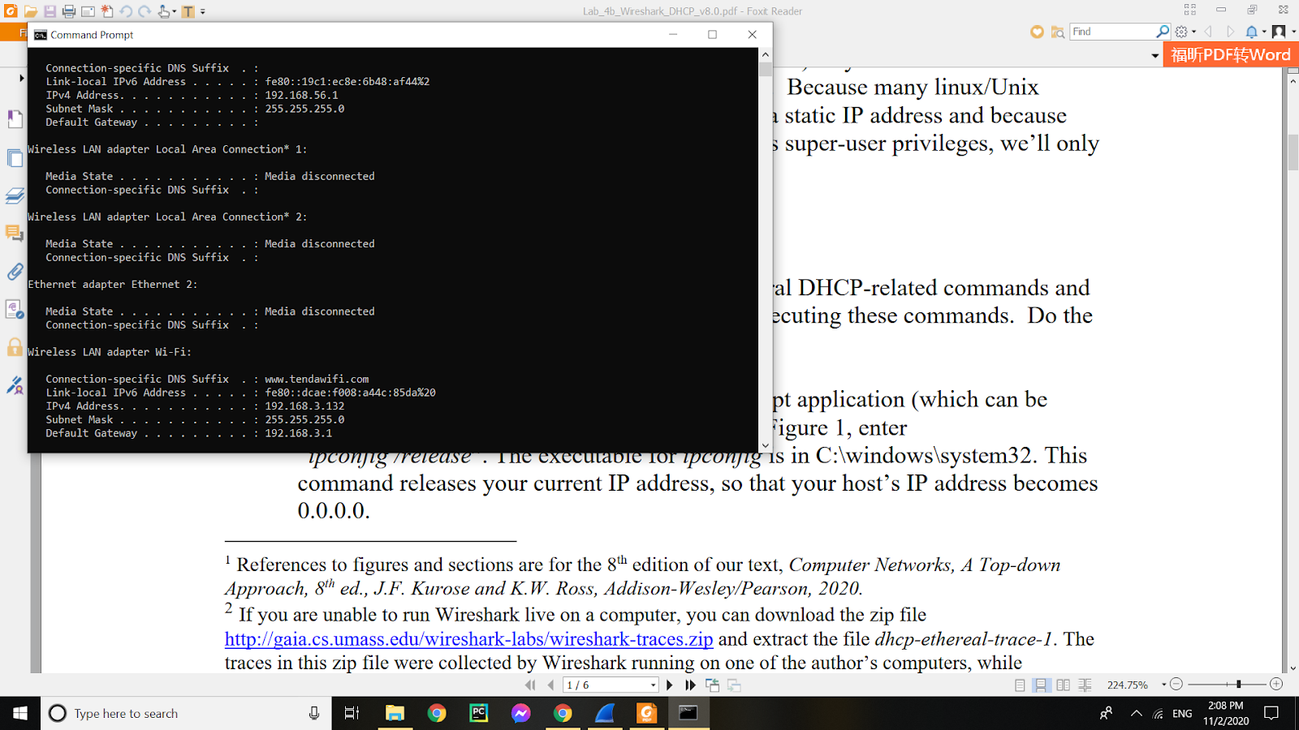

1. What are the SSIDs of the two access points that are issuing most of the beacon frames in this trace?

* They are Linksys_SES_24086 and 30 Munroe St.

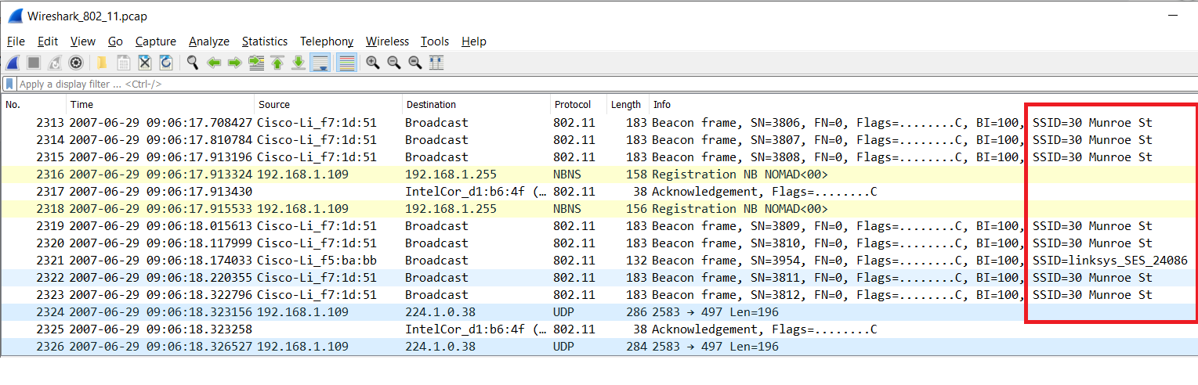

1. What are the intervals of time between the transmissions of the beacon frames the linksys_ses_24086 access point? From the 30 Munroe St. access point?

* They are approximately 0.1024 s.

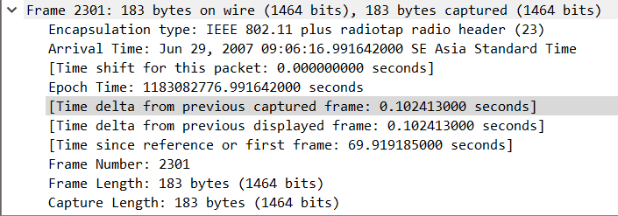

1. What (in hexadecimal notation) is the source MAC address on the beacon frame from 30 Munroe St? Recall from Figure 7.13 in the text that the source, destination, and BSS are three addresses used in an 802.11 frame.

* The source MAC address on the beacon frame from 30 Munroe is 00:16:b6:f7:1d:51.

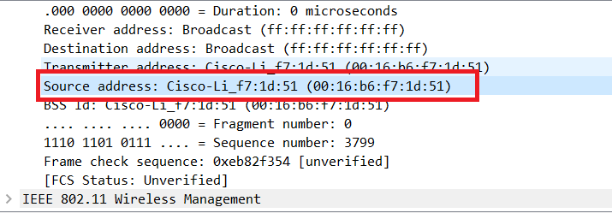

1. What (in hexadecimal notation) is the destination MAC address on the beacon frame from 30 Munroe St??

* The destination MAC is for broadcast. The destination MAC is ff:ff:ff:ff:ff:ff.

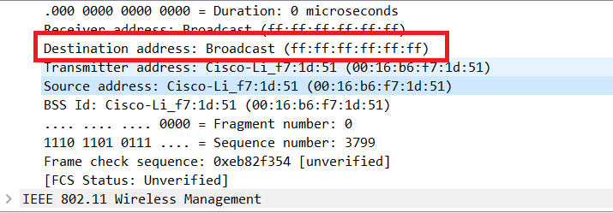

1. What (in hexadecimal notation) is the MAC BSS id on the beacon frame from 30 Munroe St?

* The MAC BSS is on the beacon frame from 30 Munroe St is 00:16:b6:f7:1d:51.

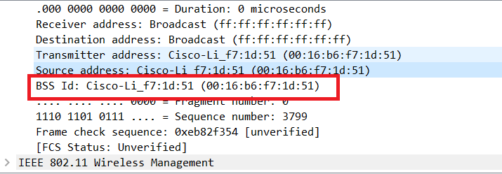

1. The beacon frames from the 30 Munroe St access point advertise that the access point can support four data rates and eight additional “extended supported rates.” What are these rates?

* The eight additional “extended supported rates” are 6, 9, 12, 18, 24, 36, 48, 54 Mbps.
* Mbps and four data rates are 1, 2, 5.5, 11 Mbps.

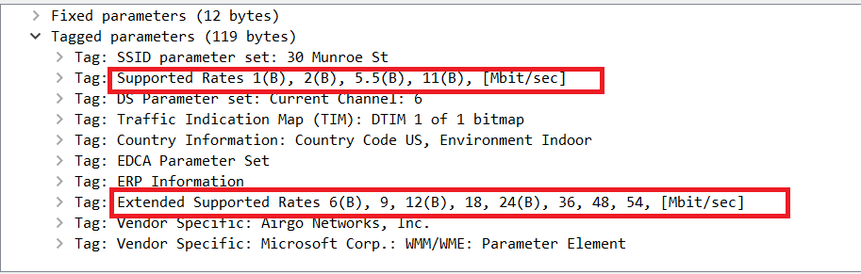

1. Find the 802.11 frame containing the SYN TCP segment for this first TCP session (that downloads alice.txt). What are three MAC address fields in the 802.11 frame? Which MAC address in this frame corresponds to the wireless host (give the hexadecimal representation of the MAC address for the host)? To the access point? To the first-hop router? What is the IP address of the wireless host sending this TCP segment? What is the destination IP address? Does this destination IP address correspond to the host, access point, first-hop router, or some other network-attached device? Explain.

* Those MAC addresses are BSSid, source address and destination.
* The MAC address corresponding to the wireless host is 00:13:02:d1:b6:4f. Corresponding to the first hop router is 00:16:b6:f4:eb:a8. Corresponding to the wireless host sending this TCP segment is 00:16:b6:f7:1d:51.
* The corresponding IP of the wireless host is 192.168.1.109.
* The destination IP is 128.199.245.12 and this IP corresponds to the host.

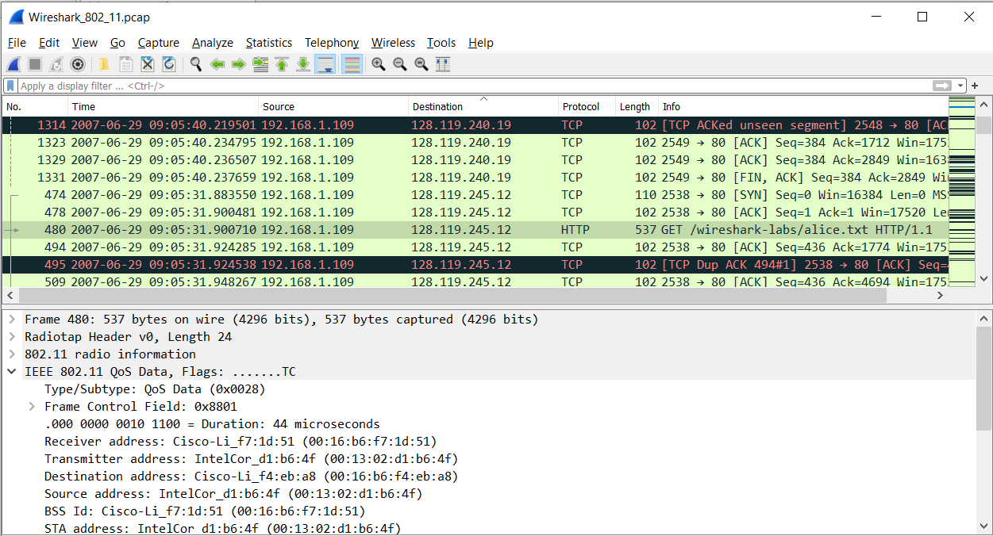

1. Find the 802.11 frame containing the SYNACK segment for this TCP session. What are three MAC address fields in the 802.11 frame? Which MAC address in this frame corresponds to the host? To the access point? To the first-hop router? Does the sender MAC address in the frame correspond to the IP address of the device that sent the TCP segment encapsulated within this datagram?

* Three MAC address fields in the 802.11 frame are BSS id: 00:16:b6:f7:1d:51, Destination: 00:13:02:d1:b6:4f and source address: 00:16:b6:f4:eb:a8.
* The MAC corresponding to the host is 00:13:02:d1:b6:4f (destination).
* The MAC corresponding to the first hop is 00:16:b6:f4:eb:a8 (Source).
* The sender MAC address in the frame does not correspond to the IP address of the device that sent the TCP segment encapsulated within this datagram, because the TCP SYNACK’s IP address is 128:199:245:12 but the destination IP address is 192.168.1.109.

.

1. What two actions are taken (i.e., frames are sent) by the host in the trace just after t=49, to end the association with the 30 Munroe St AP that was initially in place when trace collection began? Looking at the 802.11 specification, is there another frame that you might have expected to see, but don’t see here?

* A DHCP is sent to 192.168.1.1
* The host sends a DEAUTHENTICATION frame after 0.02s
* We expected to see a Disassociation request.

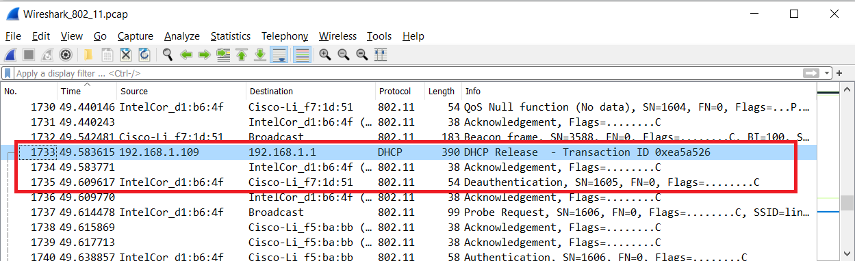

1. Examine the trace file and look for AUTHENTICATION frames sent from the host to an AP and vice versa. How many AUTHENTICATION messages are sent from the wireless host to the linksys_ses_24086 AP (which has a MAC address of Cisco_Li_f5:ba:bb) starting at around t=49? .

* There are 17 AUTHENTICATION messages from the wireless host to the linksys_ses_24086 AP.

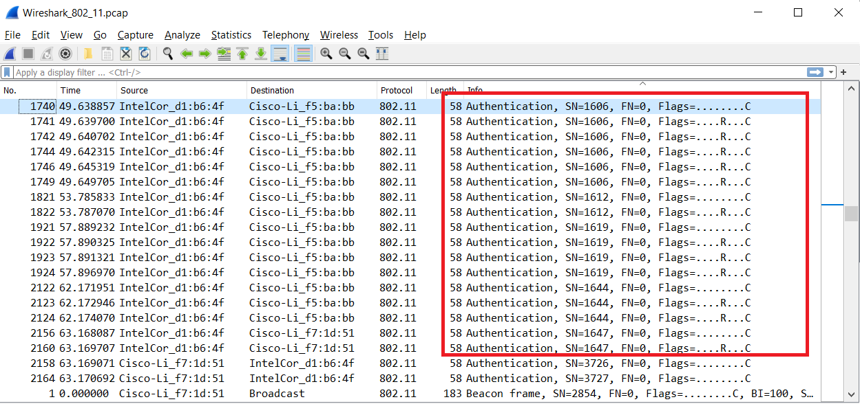

1. Does the host want the authentication to require a key or be open?

* Yes, it does

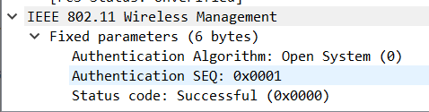

1. Do you see a reply AUTHENTICATION from the linksys_ses_24086 AP in the trace?

* No, there is no reply AUTHENTICATION from the linksys_ses_24086 AP in the trace.

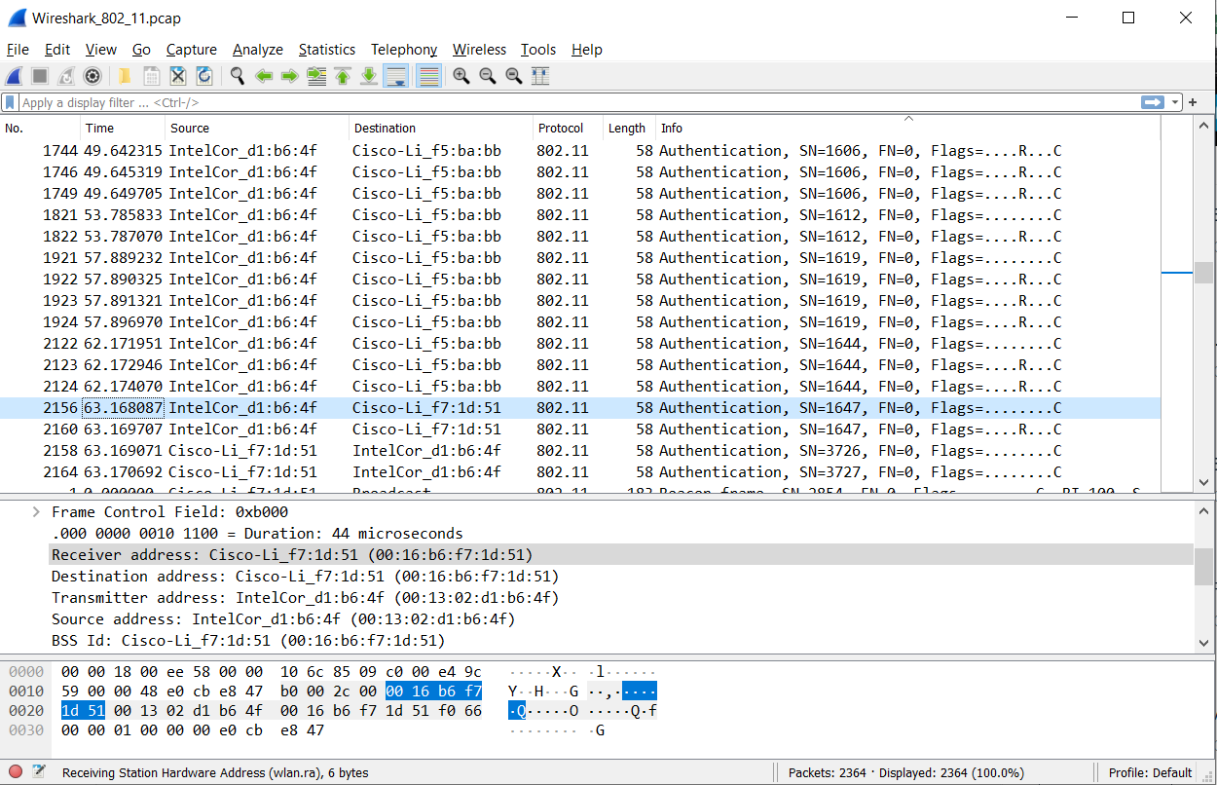

1. Now let’s consider what happens as the host gives up trying to associate with the linksys_ses_24086 AP and now tries to associate with the 30 Munroe St AP. Look for AUTHENTICATION frames sent from the host to and AP and vice versa. At what times is there an AUTHENTICATION frame from the host to the 30 Munroe St. AP, and when is there a reply AUTHENTICATION sent from that AP to the host in reply?

* There is an AUTHENTICATION frame from 00:13:02:d1:b6:4f to 00:16:b7:f7:1d:51 when t = 63.168087. The AUTHENTICATION sent back at t = 63.169071.

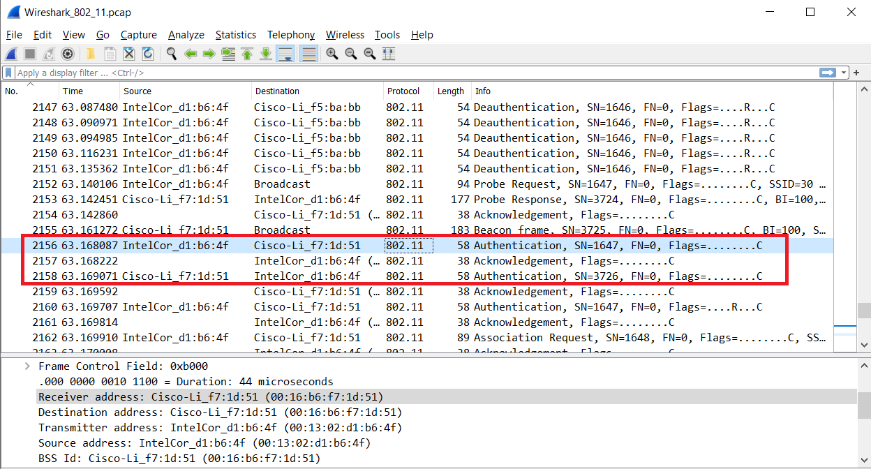

1. An ASSOCIATE REQUEST from host to AP, and a corresponding ASSOCIATE RESPONSE frame from AP to host are used for the host to be associated with an AP. At what time is there an ASSOCIATE REQUEST from host to the 30 Munroe St AP? When is the corresponding ASSOCIATE REPLY sent?

* ASSOCIATE REQUEST from host to the 30 Munroe St AP at t = 63.169910 and replied at t = 63.192101.

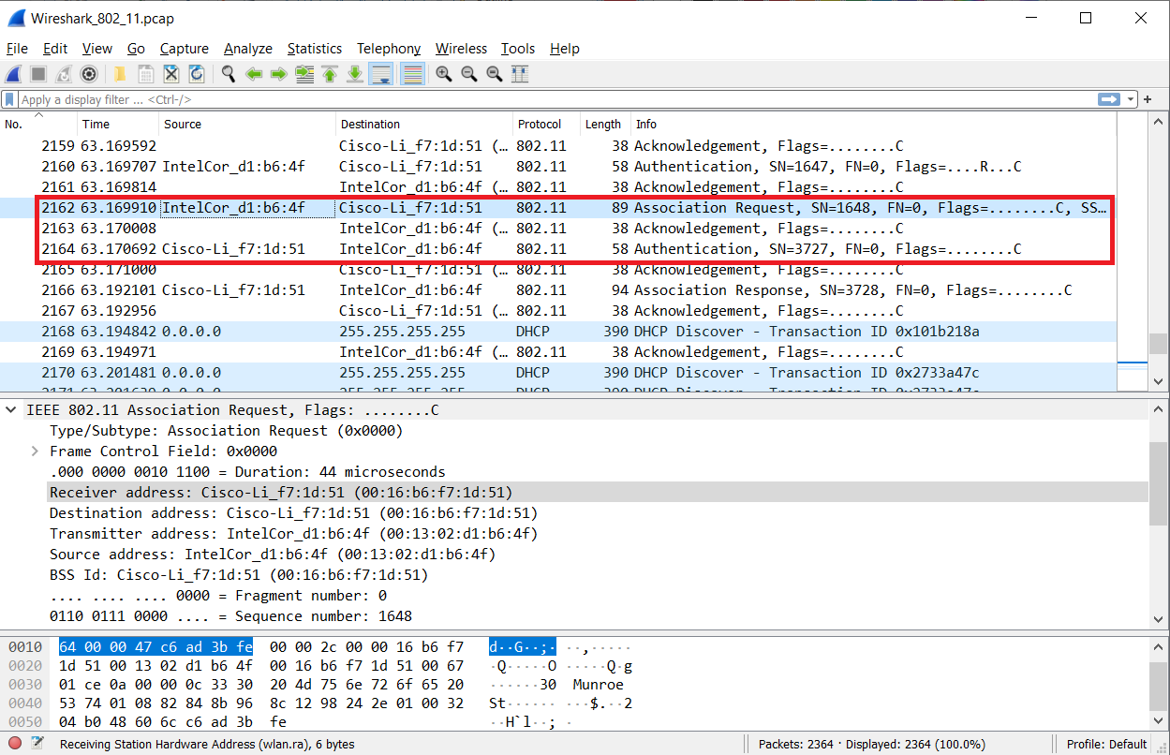

1. What transmission rates is the host willing to use? The AP?

* Host transmission: 1, 2, 5.5, 11, 6, 9, 12, 18 Mbps
* Extended rates: 24, 36, 48, 54 Mbps

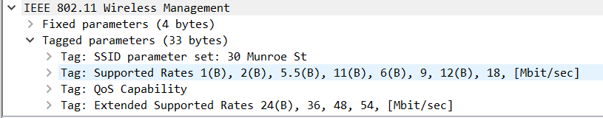

* AP transmission rates: 1, 2, 5.5, 11 Mbps
* Extended rates: 6, 9, 12, 18, 24, 36, 48 and 54 Mbps

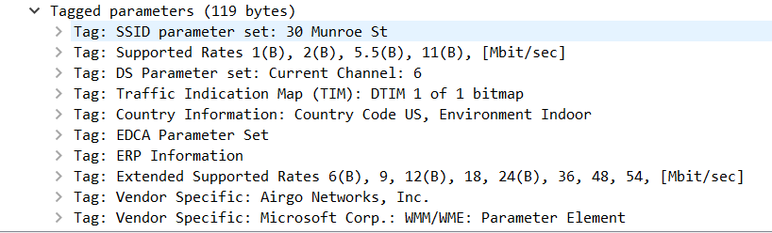

1. What are the sender, receiver and BSS ID MAC addresses in these frames? What is the purpose of these two types of frames?

* Probe request: Source: 00:12:f0:1f:57:13, destination: ff:ff:ff:ff:ff:ff, BSSID: ff:ff:ff:ff:ff:ff
* Probe response: Source: 00:16:b6:f7:1d:51, destination: 00:16:b6:f7:1d:51, BSSID: 00:16:b6:f7:1d:51
* The probe request is a broadcast to scan for an access point from the host. The probe response is used to respond to the host from the access point .